«Gothic»
Tech & Promotional Demo
Latest change: 29.07.2026
Authors: Dmitriy Phantom95
© 2020 GMT
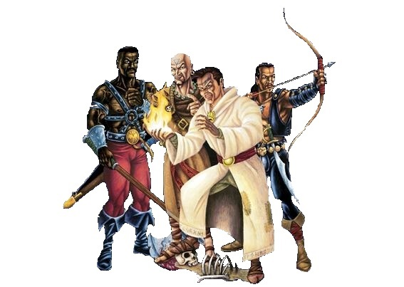
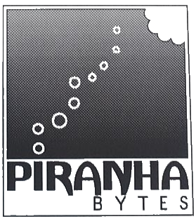

CREDITS
For the game and provided materials:
Piranha Bytes

For this document:
Phantom95

For chronology and provided pre-release materials:
Odin68
Lali

For research and active search for material on early versions of Gothic:
Lali
Sporthistoriker
Vaana
Odin68
MaGoth
Dr.Horatio
FlatcherGoth
Psimek
Trojan
Асмал
Voron25

For creating documentary videos:
Psimek
Vaana
FlatcherGoth

For support and active interest in discussing the topic of alpha versions of Gothic:
Dr.Horatio
ArnoldNovikov
Bezio
Trojan
Voron25
FlatcherGoth
Odin68
MaGoth
Sporthistoriker
Lali
Vaana
Catalinux
Psimek
Drurhang
Gor
Ur-Trall
Стражник
Асмал
IdeaGen

Table of Content
Table of Content 3
1. Gothic Demo №1 4
2. Gothic Demo №2 5
3. Gothic Demo №3 6
4. Gothic Demo №4 7
5. Gothic Demo №5 8
6. Gothic Demo №6 9
7. Gothic Demo №7 10
8. Gothic Demo №8 11
9. Gothic Demo №9 12
10. Gothic Demo №10 13
11. Gothic Demo №11 14
12. Gothic Demo №12 15
13. Gothic Demo №13 16
14. Gothic Demo №14 17
15. Gothic Demo №15 18
16. Gothic Demo №16 19
17. Gothic Demo №17 20
18. Gothic Demo №18 21

Gothic Demo №1
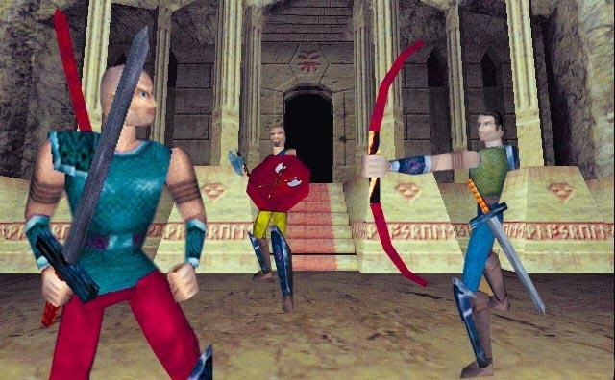

Production date: February 1998

Status: Pre Alpha

Version: ?

Existence: Unknown

Advertising: Screenshots

World: AncientTemple1.pwf

Music: ?

Gothic Demo №2
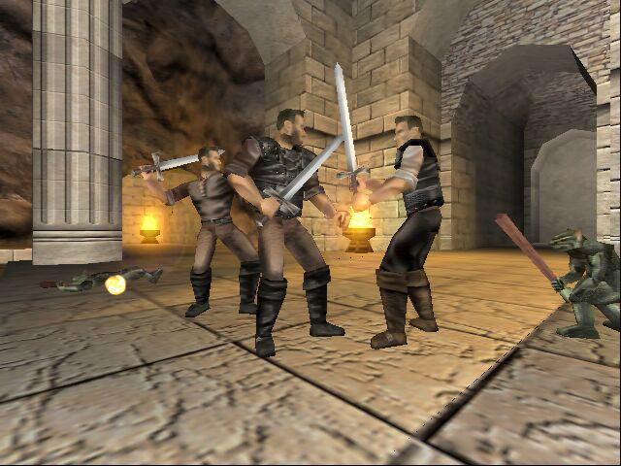

Production date: July 1998

Status: Pre Alpha

Version: ?

Existence: Unknown

Advertising: Screenshots

World: Demo2.pwf

Music: ?

Gothic Demo №3
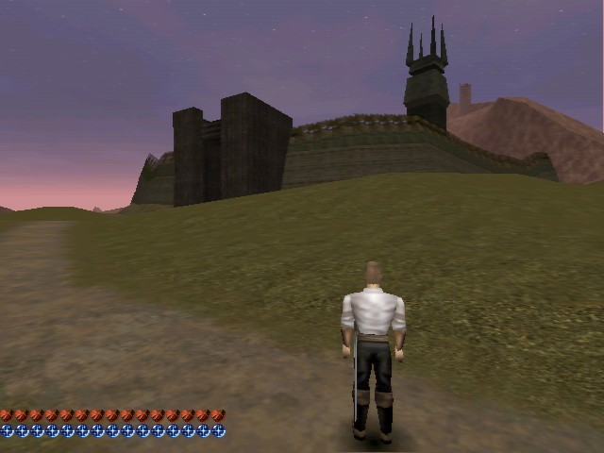

Production date: March 1999

Status: Pre Alpha

Version: 0.56c

Existence: Exist

Advertising: Screenshots & Trailer for E3 1999

World: Surface.pwf (Proto OW v1 + OC v1)

Music: Proto v1

Gothic Demo №4
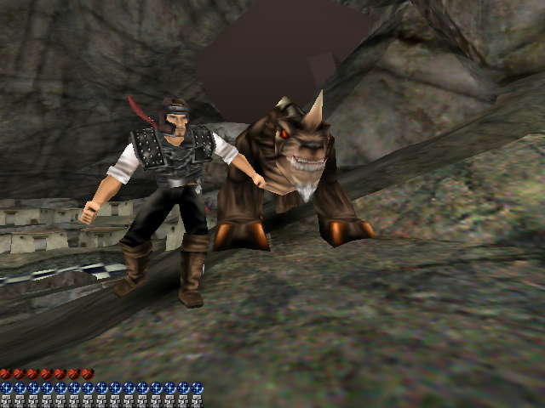

Production date: May 1999

Status: Pre Alpha

Version: ?

Existence: Unknown

Advertising: Screenshots

World: Surface.pwf (Proto OW v1 + OC v1 + NC v1)

Music: Proto v1

Gothic Demo №5
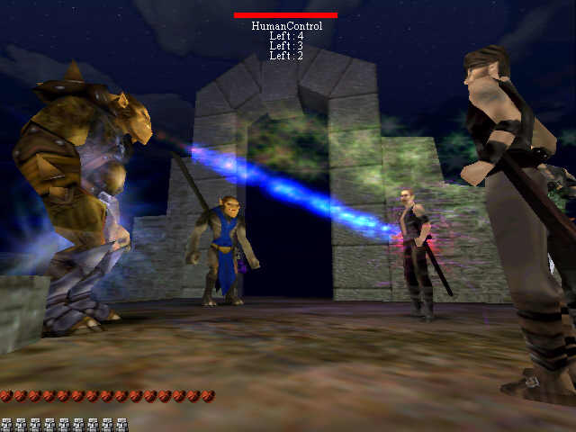

Production date: July 1999

Status: Pre Alpha

Version: 0.64b

Existence: Exist

Advertising: Screenshots and Video reports from GameStar (09/1999) and PC Games (11/1999)

World: World.zen (Proto OW v2 + OC v1 + NC v1 + PC v1)

Music: Proto v1

Gothic Demo №6
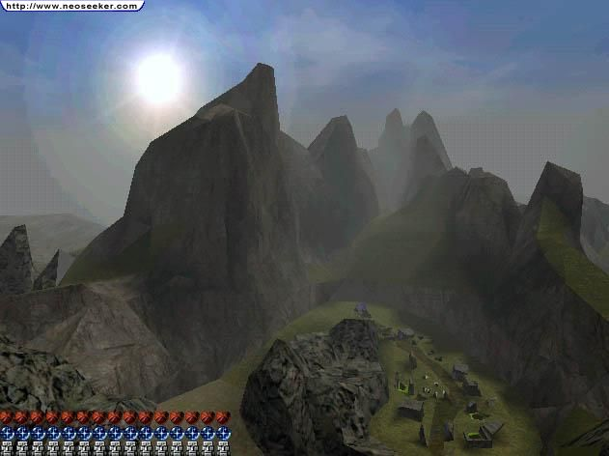

Production date: August 1999

Status: Pre Alpha

Version: 0.66 (Need proof)

Existence: Unknown

Advertising: Screenshots

World: World.zen (Proto OW v3 + OC v2 + NC v1 + PC v1)

Music: ?

Gothic Demo №7
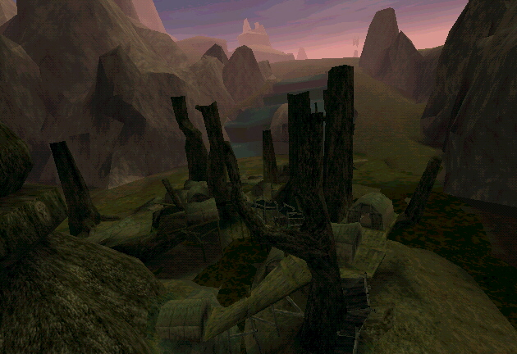

Production date: September 1999

Status: Pre Alpha

Version: 0.67 (Need proof)

Existence: Unknown

Advertising: Screenshots

World: World.zen (Proto OW v3 + OC v2 + NC v1 + PC v1)

Music: ?

Gothic Demo №8
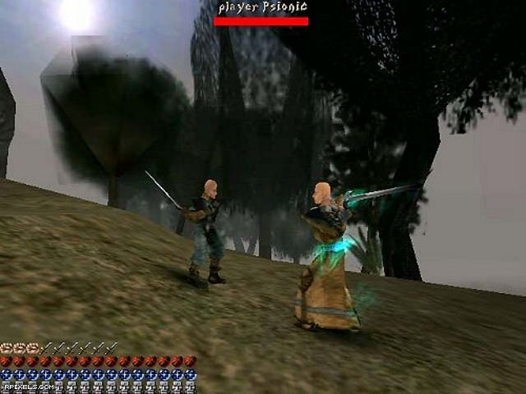

Production date: October 1999

Status: Pre Alpha

Version: 0.68 (Need proof)

Existence: Unknown

Advertising: Screenshots

World: World.zen (Proto OW v3 + OC v2 + NC v1 + PC v1)

Music: ?

Gothic Demo №9
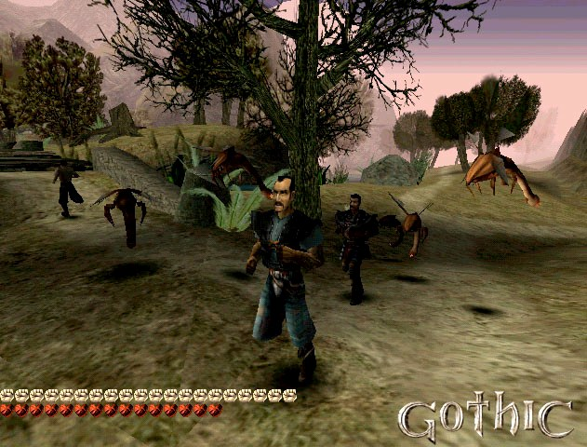

Production date: November 1999

Status: Pre-Alpha

Version: 0.69 (Need proof)

Existence: Unknown

Advertising: Screenshots & Video for PC Action (12/1999)

World: World.zen (OW v1 + OC v2 + NC v2 + PC v2 + All dungeons)

Music: ?

Gothic Demo №10
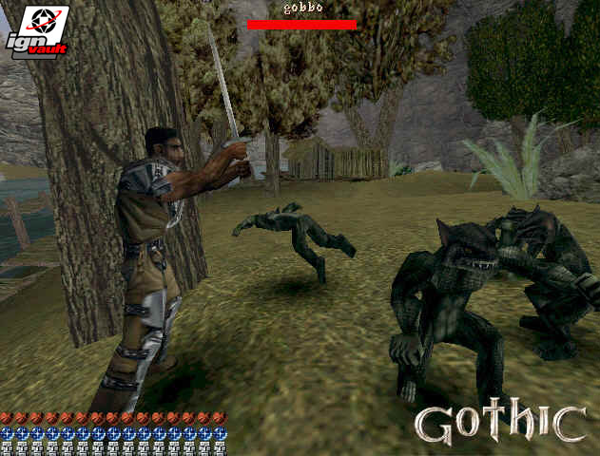

Production date: March 2000

Status: Pre-Alpha

Version: 0.74 (Need proof)

Existence: Unknown

Advertising: Screenshots & Trailer for E3 2000

World: World.zen (OW v2 + OC v2 + NC v2 + PC v2 + All dungeons)

Music: ?

Gothic Demo №11
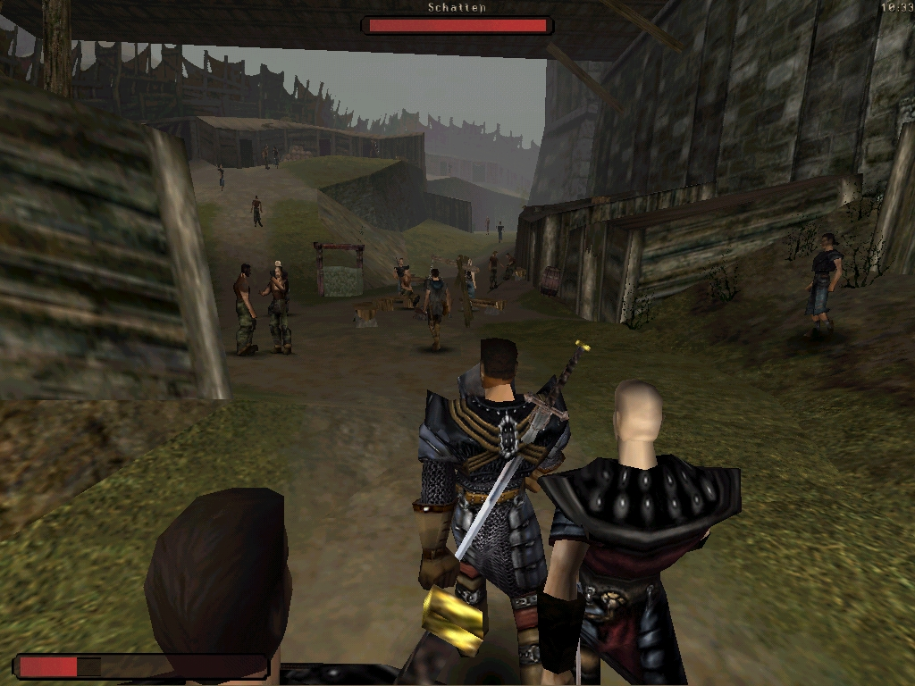

Production date: May 2000

Status: Alpha

Version: 0.82 (Need proof)

Existence: Unknown

Advertising: Screenshots

World: World.zen (OW v2 + OC v2 + NC v2 + PC v2 + All dungeons)

Music: ?

Gothic Demo №12
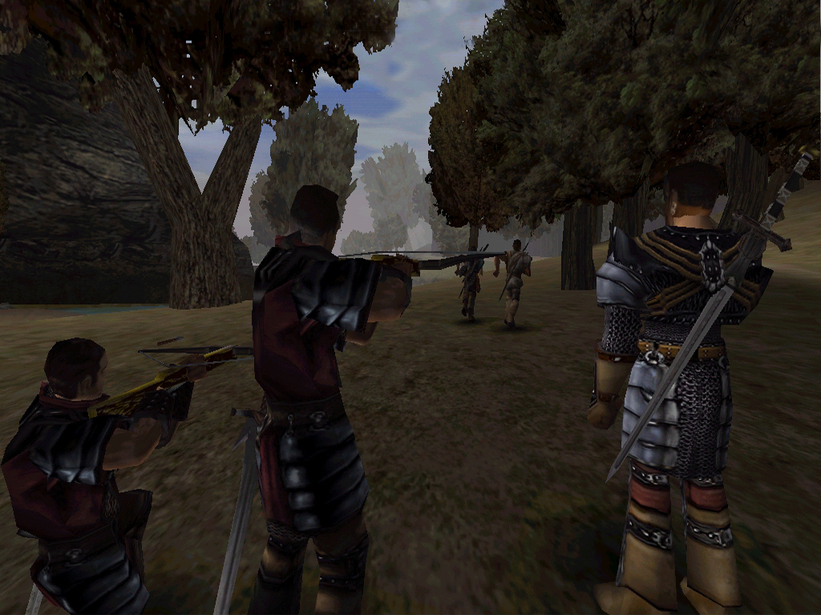

Production date: September 2000

Status: Alpha

Version: 0.92 (Need proof)

Existence: Unknown

Advertising: Screenshots and ECTS

World: World.zen (OW v3 + OC v2 + NC v2 + PC v2 + All dungeons)

Music: v1

Gothic Demo №13
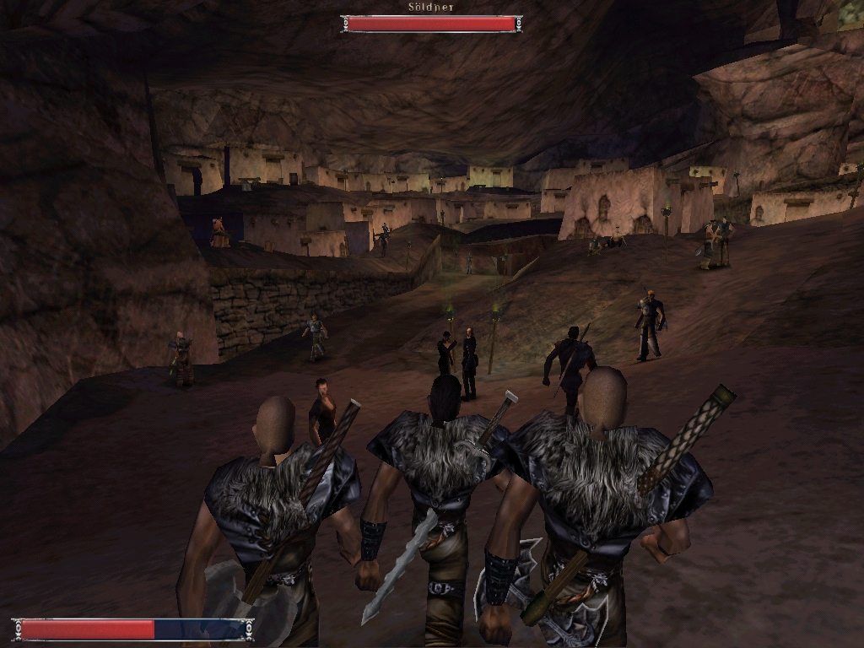

Production date: October 2000

Status: Alpha

Version: 0.94

Existence: Unknown

Advertising: Unknown

World: World.zen (OW v3 + OC v2 + NC v2 + PC v2 + All dungeons)

Music: v1

Gothic Demo №14
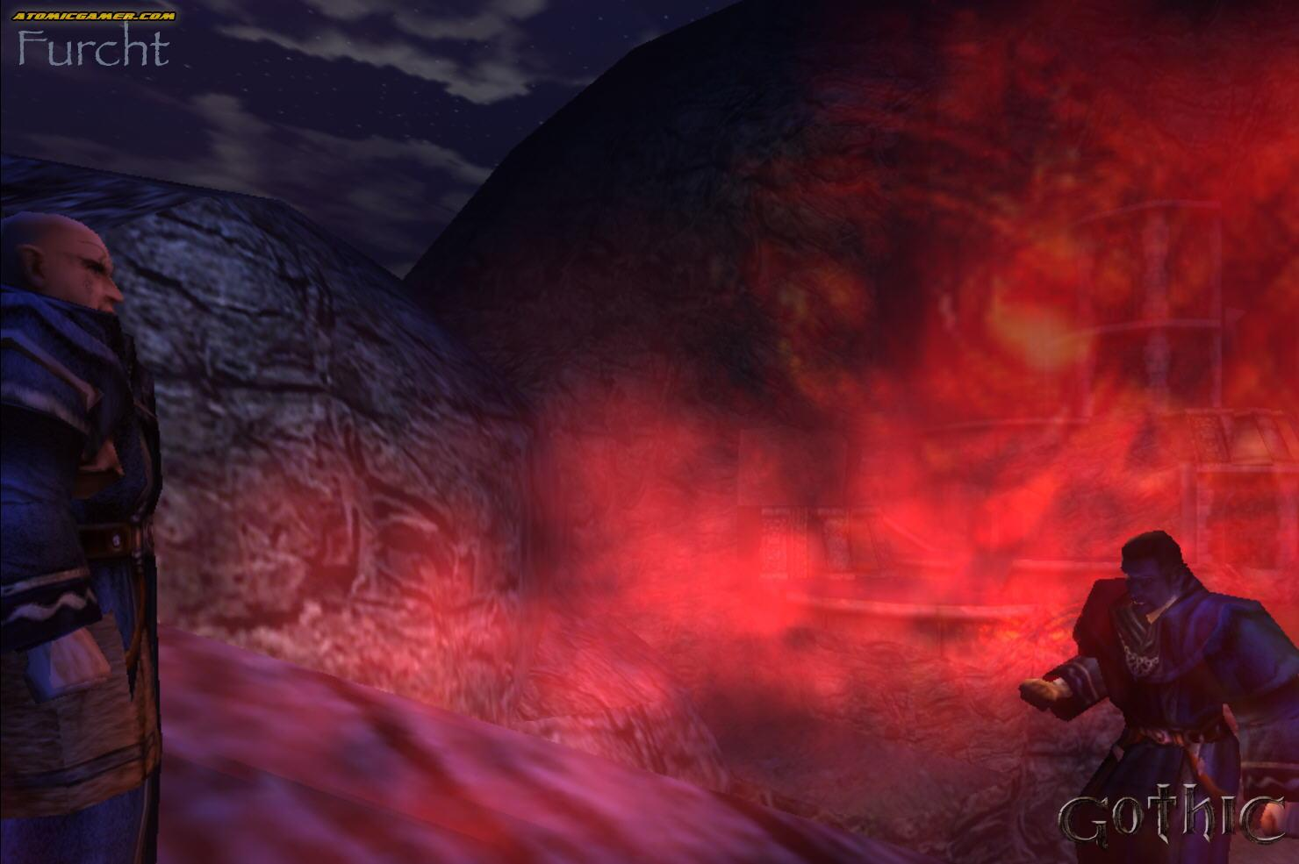

Production date: November 2000

Status: Pre Beta

Version: 0.99pre

Existence: Unknown

Advertising: Internal Demo for Publisher

World: World.zen (OW v3 + OC v2 + NC v2 + PC v2 + All dungeons)

Music: v1

Gothic Demo №15
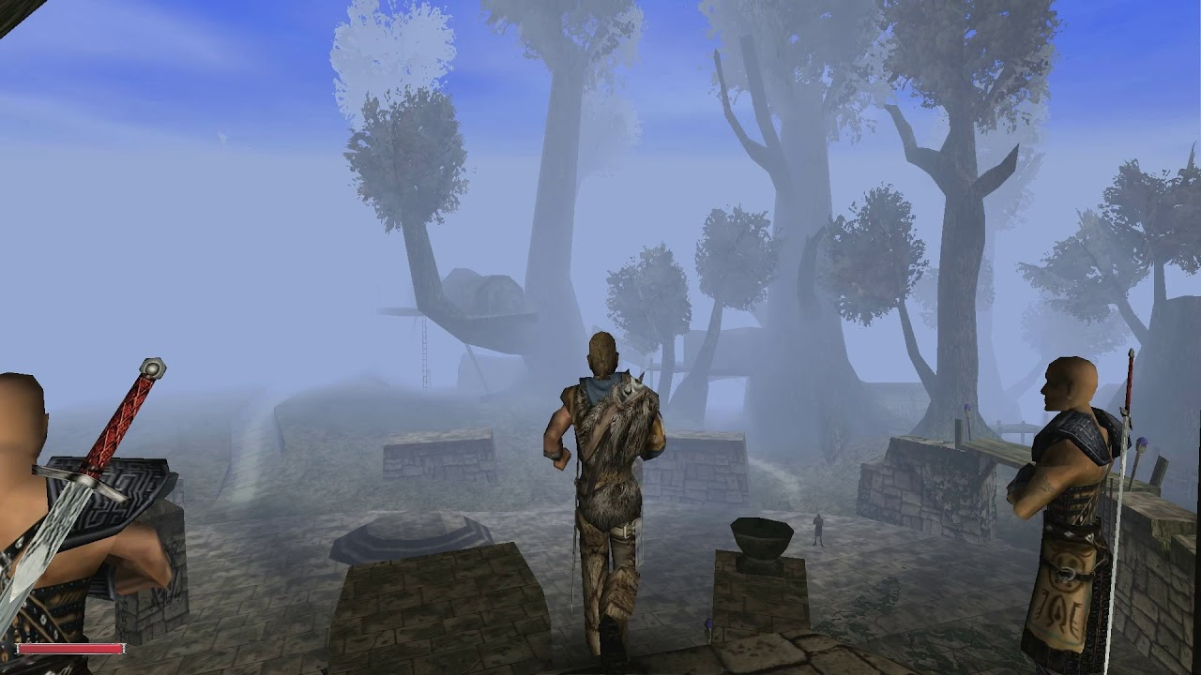

Production date: January 2001

Status: Beta

Version: 1.01d/1.01e

Existence: Open Access

Advertising: Screenshots and Video for GameStar, PC Player, PC Games (03/2001)

World: World.zen (OW v4 + OC v3 + NC v3 + PC v3 + All dungeons, without Freemine – Abandonedmine – OrcCity)

Music: v1

Gothic Demo №16
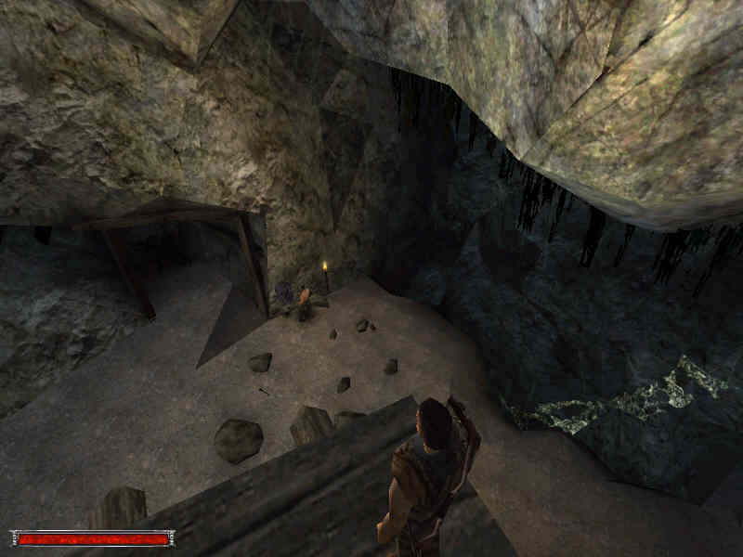

Production date: February 2001

Status: Beta

Version: 1.04d

Existence: Open Access

Advertising: Screenshots and publication

World: Oldmine.zen

Music: v2

Gothic Demo №17
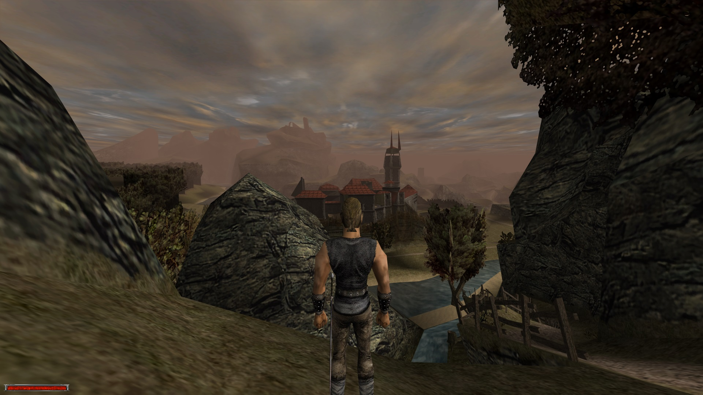

Production date: March 2001

Status: Release

Version: 1.07c

Existence: Open Access

Advertising: Screenshots and publication

World: World.zen (OW v4 + OC v3 + NC v3 + PC v3)

Music: v2

Gothic Demo №18
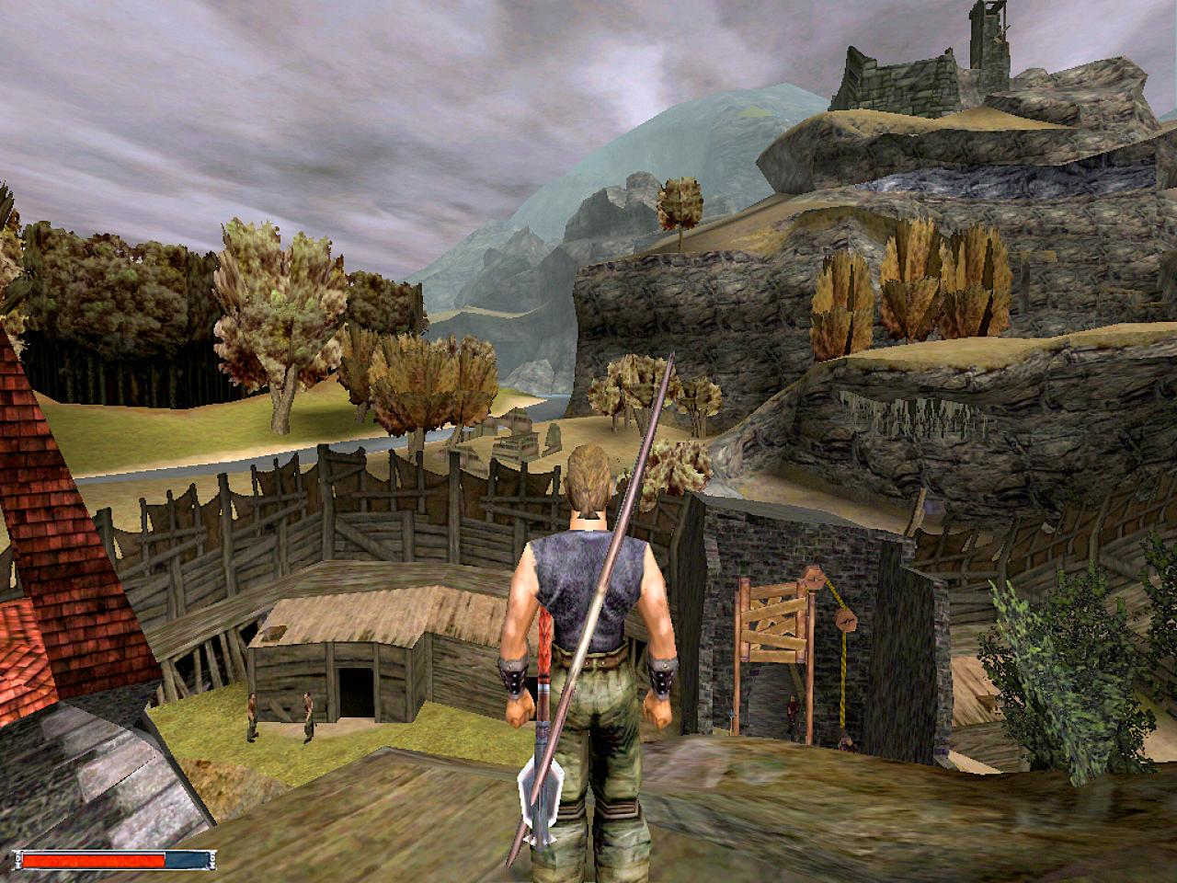

Production date: August 2001

Status: Release

Version: 1.08j

Existence: Open Access

Advertising: ECTS 2001, Screenshots and publication

World: World.zen (OW v4 + OC v3 + NC v3 + PC v3)

Music: v2

